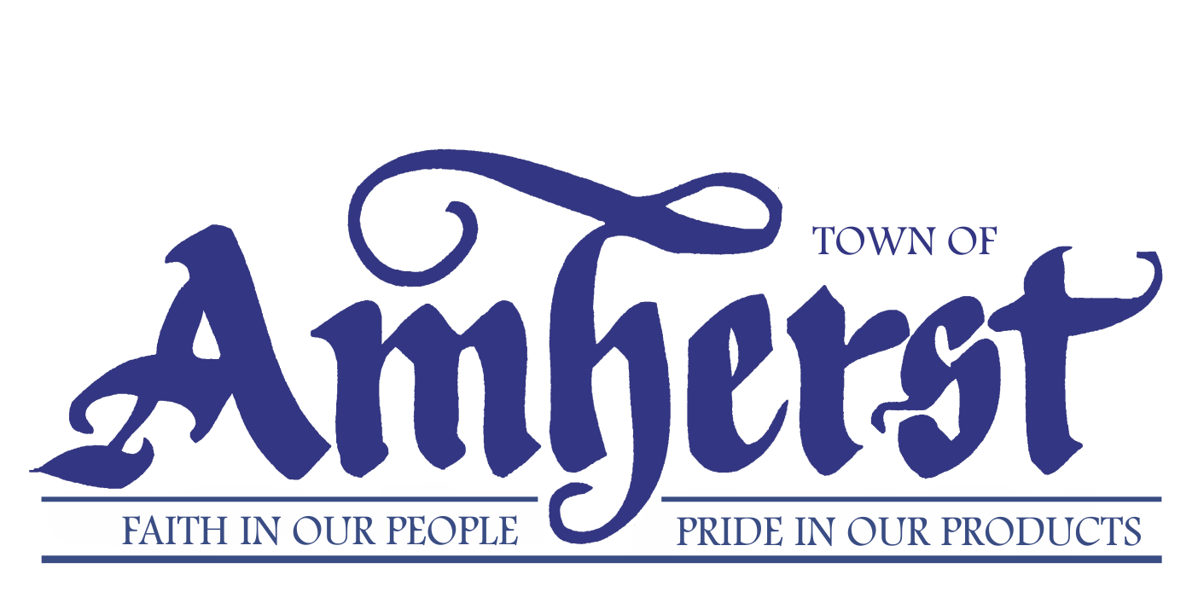

MEDIA RELEASE

FOR IMMEDIATE RELEASE MR# 2018071
DATE: 11 September 2018
RE: Skaters now required to wear CSA-certified helmets at Amherst Stadium
AMHERST, Nova Scotia – You’ll need a Canadian Standard Association-certified helmet as well as your skates the next time you want to take a spin around the rink at the Amherst Stadium.
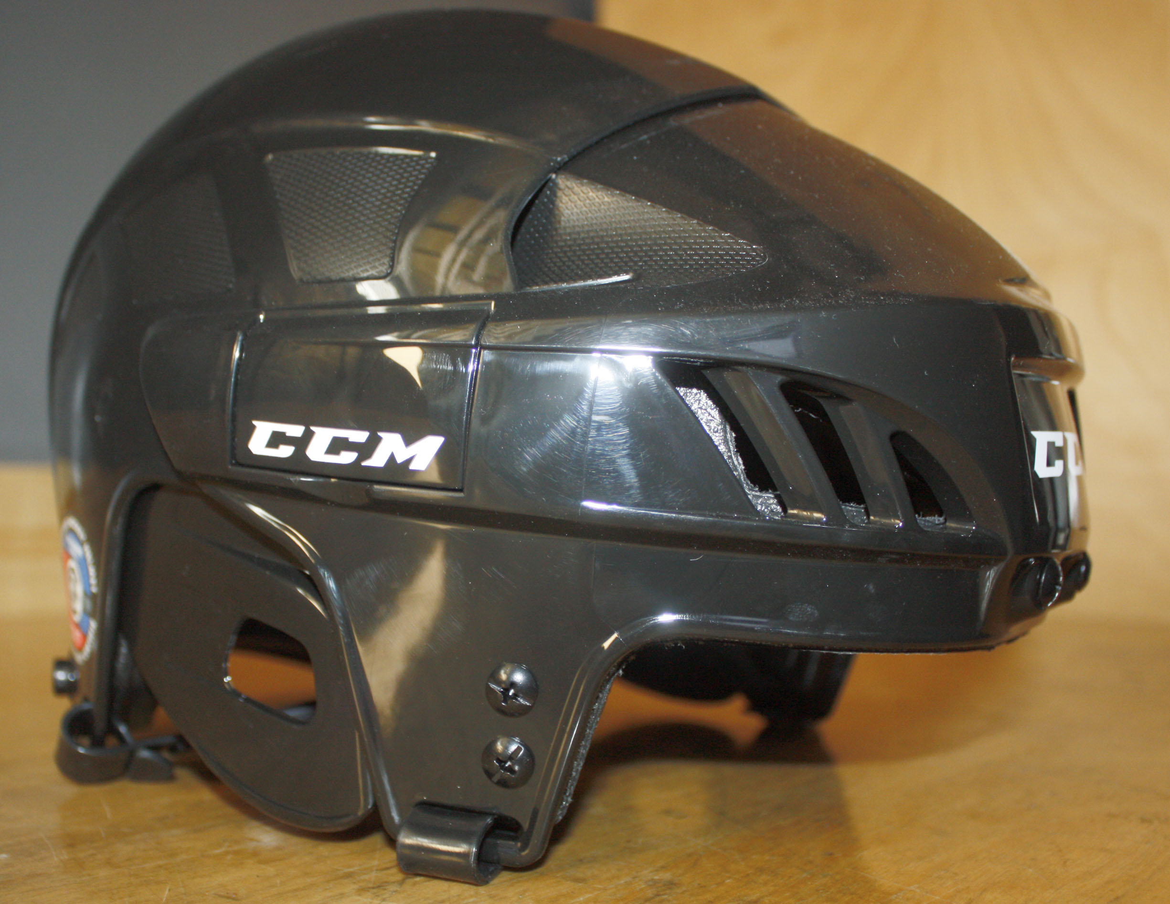“The Town of Amherst is committed to the safety of all individuals and groups using the stadium” Recreation Director Bill Schurman said. “It was felt that making the wearing of CSA-approved helmets mandatory improves the safety for those using the ice surface.”
Amherst town council approved the move to mandatory helmet use last June following a review of its previous policy. The review was sparked by feedback from several citizens who were concerned the town’s former helmet policy just strongly recommended the use of a helmet.
Skaters who take a spin around the rink at the Amherst Stadium are now required to wear a CSA-approved helmet like this one. (Town of Amherst photo)
The review, conducted by the Recreation Department, noted Hockey Nova Scotia requires all coaches to wear a CSA certified helmet while on the ice conducting practices and several other rinks throughout the province had already adopted a mandatory helmet use policy.
The new mandatory-helmet policy went into effect on Aug. 15, about four days before the town began putting the ice back into the rink. It states all individuals and groups are to wear CSA-approved ice helmets while on skates on the stadium’s ice surface and the chinstrap must be securely fastened under the chin.
Failure to wear an approved CSA helmet will “result in the removal of the individual from the ice surface until they are wearing an approved helmet,” the policy says.
Getting a helmet to wear if you forget yours or don’t have one shouldn’t be a problem. There are loaner helmets available at the stadium, thanks to a facility development grant that was received from the Province of Nova Scotia.
“They will be available on a first-come, first-served basis,” Schurman said.
The first public skating session is scheduled for Sept. 13 during ‘A’ Fest, when people will have the chance to skate with members of the Amherst Rambler Jr. A team.
All public skating sessions are free as part of the town’s efforts to encourage physical activity and becoming the most health, active community in Nova Scotia.
-30-

Direct Inquiries to:
Tom McCoag
Corporate Communications Officer
902-694-6265
tmccoag@amherst.ca
Amherst.ca

