

MEDIA RELEASE

FOR IMMEDIATE RELEASE MR# 2018070
DATE: 11 September 2018
RE: Amherst Bantam Baseball given Community Support Grant
AMHERST, Nova Scotia – Amherst Bantam Baseball has been given a $250 Community Support Grant by the Town of Amherst.
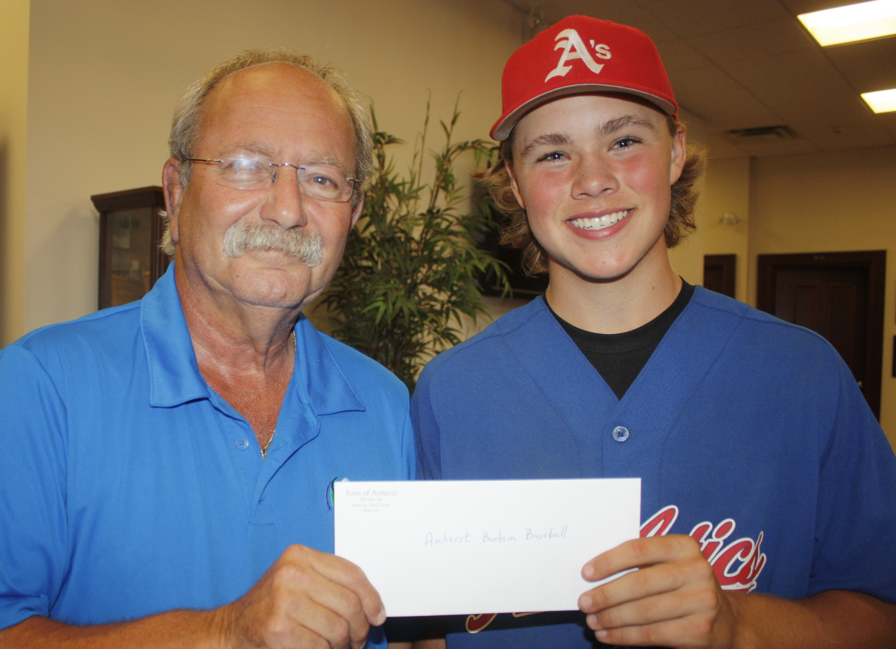The money will help the organization defray the cost of hosting the U15 Baseball Atlantic Championships, which is being held at the Robbs Centennial Complex from Sept. 14 to Sept. 16.
“Hosting an Atlantic championship takes a lot of commitment, which the organization – its coaches, players and volunteers – have shown in abundance,” Mayor David Kogon said in presenting the cheque to team member Jayden Matheson.
“The Town of Amherst is a big supporter of physical fitness. Playing baseball is just one of the many ways people can be active and enjoy a healthy lifestyle.
Mayor David Kogon presents Amherst Bantam AA Athletics Jayden Matheson with a $250 Community Support Grant. The grant will help the team defray the costs of hosting the U15 Baseball Atlantic Championships.
“The town is very proud of the Amherst Bantam AA Athletics and is very happy that we can help them host the Atlantic Championships by provide this community support grant. We wish the team luck as it pursues its goal of winning a championship and encourage residents to head down to the Robb complex to cheer on all the participating teams.”
“We are very pleased with the support we have received from the town through the Community Support Grant as well as the continued support we have received from Bill Schurman, Corey Crocker and the recreation department,” Amherst Athletics coach Darrell Cole said.
“Hosting an event like this comes with a significant price tag and the support from the town through the community support grant helps with that.”
Teams playing in the tournament are the: Amherst Athletics (host), Clark’s Harbour Foggies (N.S. champs), Riverview A’s (N.B. champs), Moncton Cubs (N.B. Team 2), St. John’s Capitals (N.L.) champs, Conception Bay North Bulldogs (N.L. Team 2), Cardigan Clippers (P.E.I. Champs) and Summerside Chevys (P.E.I.) Team 2.
Play gets underway on Sept. 14 and 15 at 8 a.m. The bronze medal game goes at 10 a.m. on Sept. 16, while the championship game starts at 1 p.m. (The schedule for the entire tournament is below the news release.)
“It’s an honour for Amherst to be selected to host the 2018 Atlantic bantam AA baseball championships,” Cole said. “It’s something I’ve been wanting to do for many years. There is a strong tradition of baseball in Cumberland County stretching back through the generations and this tournament is an opportunity for us to showcase our talent as well as Amherst as host to major sporting events.
“We have a very competitive team this year. We have a number of players back from our team that won the Baseball NS Bantam A silver medal last year, while two members of last year’s provincial bantam AA runner-up Springhill Fencebusters joined our club this year.
“We have good depth on the mound and are a good hitting team. If we get good defence through the weekend, we could be in the running for the championships. The nice thing about this tournament is it appears the teams are fairly evenly matched, so it could be anyone’s tournament to win.”
-30-

Direct Inquiries to:
Tom McCoag
Corporate Communications Officer
902-694-6265
tmccoag@amherst.ca
Amherst.ca

15U AA BASEBALL ATLANTIC CHAMPIONSHIPS 2018
POOL A POOL B
Nova Scotia 1 – Clark’s Harbour Foggies Prince Edward Island 1 – Cardigan Clippers
Newfoundland & Labrador 1 – St. John’s Caps New Brunswick 1 – Riverview A’s
Prince Edward Island 2 – Summerside Chevies Newfoundland & Labrador 2 – CBN Bulldogs
New Brunswick 2 – Moncton Cubs Nova Scotia 2 (Host) – Amherst Athletics

GM# | TIME | FIELD | VISITING TEAM |  | HOME TEAM
FRIDAY
1 | 8:00am | Cecil Small | Newfoundland Labrador 2 | vs | New Brunswick 1
2 | 8:30am | Dwight Jones | Nova Scotia 2 (Host) | vs | Prince Edward Island 1
3 | 11:00am | Cecil Small | Prince Edward Island 2 | vs | Nova Scotia 1
4 | 11:30am | Dwight Jones | New Brunswick 2 | vs | Newfoundland Labrador 1
5 | 1:45pm | Dwight Jones | OPENING CEREMONIES
6 | 2:00pm | Cecil Small | Nova Scotia 2 (Host) | vs | New Brunswick 1
 | 2:30pm | Dwight Jones | Prince Edward Island 1 | vs | Newfoundland Labrador 2
7 | 5:00pm | Cecil Small | Prince Edward Island 2 | vs | Newfoundland Labrador 1
8 | 5:30pm | Dwight Jones | Nova Scotia 1 | vs | Newfoundland Labrador 2
SATURDAY
9 | 8:00am | Cecil Small | New Brunswick 1 | vs | Prince Edward Island 1
10 | 8:30am | Dwight Jones | Newfoundland Labrador 2 | vs | Nova Scotia 2 (Host)
11 | 11:00am | Cecil Small | Newfoundland Labrador 1 | vs | Nova Scotia 1
12 | 11:30am | Dwight Jones | New Brunswick 2 | vs | Prince Edward Island 2
13 | 2:00pm | Cecil Small | 4th Place Pool A | vs | 4th Place Pool B
14 | 2:30pm | Dwight Jones | 3rd Place Pool A | vs | 3rd Place Pool B
15 | 5:00pm | Cecil Small | 2nd Place Pool B | VS | 1st Place Pool A
16 | 5:30pm | Dwight Jones | 2nd Place Pool B | VS | 1st Place Pool A
SUNDAY
17 | 10:00am | Dwight Jones | BRONZE MEDAL GAME  Loser Game 15 | vs | BRONZE MEDAL GAME  Loser Game 16
18 | 1:00pm | Dwight Jones | GOLD MEDAL GAME  Winner of Game 15 | vs | GOLD MEDAL GAME  Winner of Game 16

