

MEDIA RELEASE

FOR IMMEDIATE RELEASE MR# 2018054
DATE: 29 June 2018
RE: Electric car charger opened behind Amherst town hall
AMHERST, Nova Scotia – The electric car charging station located behind Amherst town hall is opened for business.
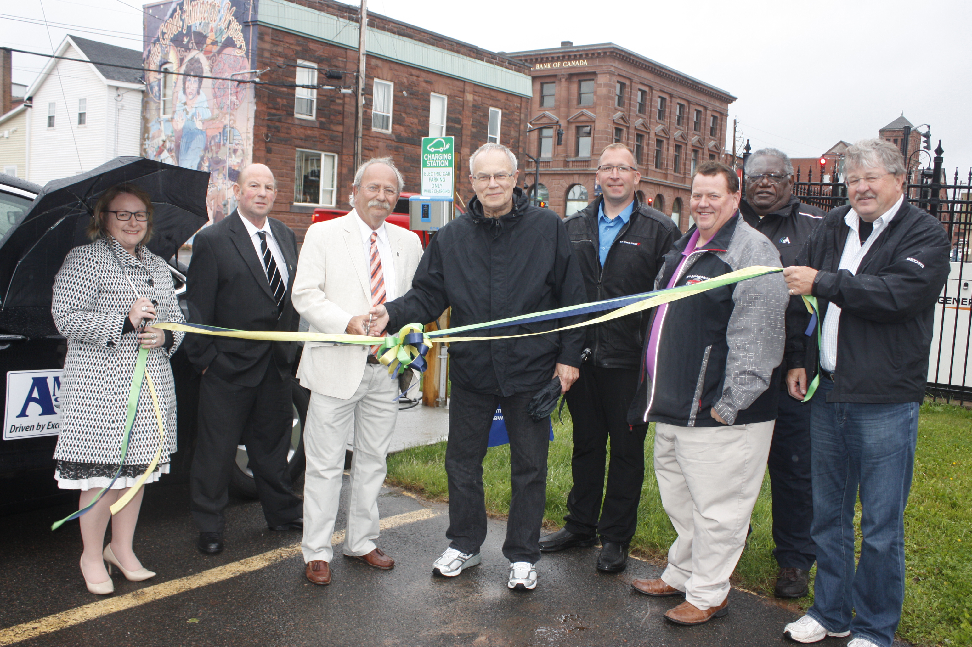Mayor David Kogon, David Stevenson, a Tatamouche resident who is a strong supporter of renewable energy, Andrew Hurley of Amherst Chrysler and members of Amherst town council cut a ribbon on June 25 to officially mark the occasion.
Stevenson, who has long dreamed of having charging stations around the province so you “could drive an electric car anywhere in Nova Scotia,” donated the charger to the town.
The electric car charging station located behind Amherst town hall was officially opened on June 25. Participating in the ribbon cutting are Deputy-Mayor Sheila Christie, Coun. Terry Rhindress, Mayor David Kogon, David Stevenson (the donator of the charger), Andrew Hurley of Amherst Chrysler, Coun. Wayne MacKenzie, Coun. Darrell Jones and Coun. Vince Arbing. (Town of Amherst photo)
Kogon thanked Stevenson for the donation and added having the charging station in town complemented the Town of Amherst’s efforts to be a green community.
A retired educator, Stevenson is currently the president of Colchester-Cumberland Wind Field, a windfarm located between Tatamagouche and Earltown.
As a result of his work with the windfarm, he met David Swan, who is a director with the windfarm and has 30 years of experience with electric cars. They in turn met up with a person in Saskatchewan who was working to put charging stations across the country.
“We all had a personal appreciation of renewable energy and wanted to work towards the ability to fuel electric vehicles anywhere in the province,” Stevenson said.
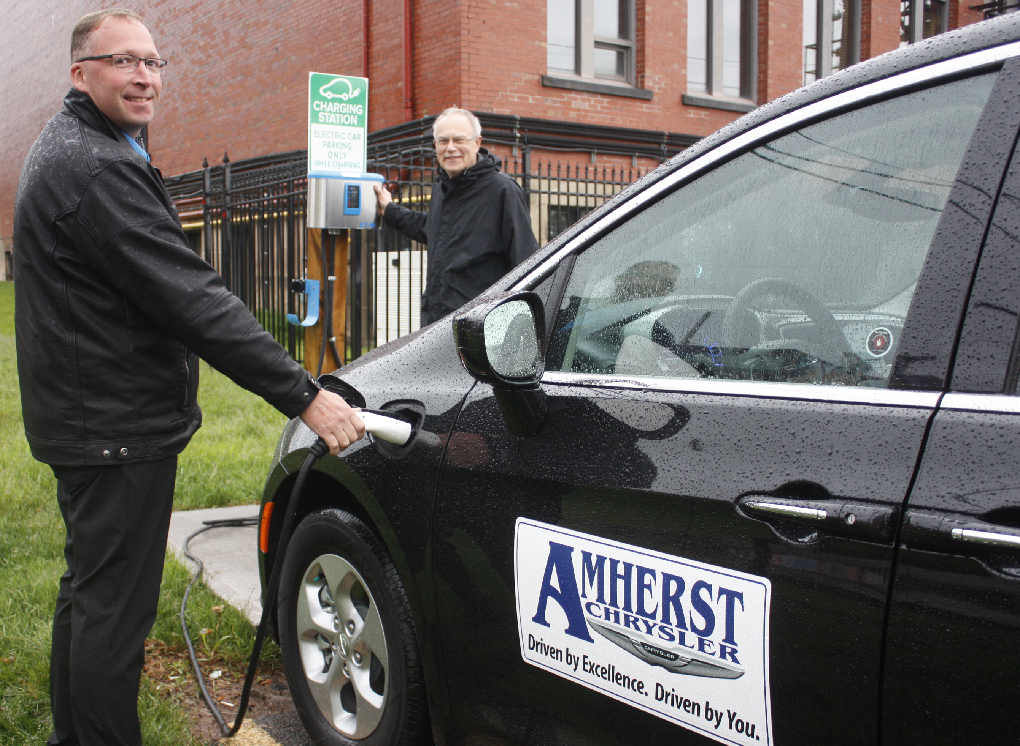In 2012, Stevenson and Swan began their volunteer work to bring charging stations to various communities in the province. Their work has resulted in charging stations in Parrsboro, Masstown, Truro, New Glasgow, Antigonish and in the Valley.
While installing a charging station in Grand Pre, they learned that Eaton was throwing away three charging stations that had been intended for a South Shore business. Stevenson and Swan contacted Eaton, asking for the chargers. Eaton declined to give them the ones they were throwing away, but donated three new chargers to them.
Andrew Hurley of Amherst Chrysler charges an electric car as David Stevenson looks on. Stevenson donated the charger to the Town of Amherst, which is located behind Amherst town hall. (Town of Amherst photo)
The charger they donated to Amherst is one of the new chargers. A slow charger, it can charge any electric car currently in use.
Stevenson praised Amherst for being innovative and supportive of renewable energy, which he said is the wave of the future and helps to cut down on the use of fossil fuels.
The charger will also attract visitors because electric car owners plan their trips around where charging stations are located, Stevenson said.
-30-

Direct Inquiries to:
Tom McCoag
Corporate Communications Officer
902-694-6265
tmccoag@amherst.ca
Amherst.ca

