

MEDIA RELEASE

FOR IMMEDIATE RELEASE MR# 2018037
DATE: 23 May 2018
RE: Amherst approves operating and capital budgets, slight tax rate increase
AMHERST, Nova Scotia – A $17.5-million operating budget, a $2.98-million capital budget and a slight increase in tax rates were approved by Amherst town council during a special session held on May 23.
“I feel extremely optimistic about the next year for the Town of Amherst,” Mayor David Kogon said. “This budget allows the town to complete necessary infrastructure projects while minimizing tax increases. The town is fortunate to be able to continue to deliver the level of services provided while minimizing tax increases even while the expenses of the town continue to be impacted by inflation on items like wages, energy costs and more.”
The new residential tax rate is $1.635 per $100 of assessment, up from $1.63. The commercial rate is $4.435 per $100 of assessment, up from $4.43. The small increase comes a year after council held the residential tax rate and decreased the commercial tax rate by two cents.
The half-cent increase is directly related to council’s desire to increase the funds available for support grants to organizations, community events and the Cumberland YMCA as well as the tax exemption bylaw and tax reduction policy. As a result, the new community support area rate, which is included in the overall tax rates, is increased to 6.5 cents per $100 of assessment from six cents.
“Even with the increase, the amount requested by organizations far exceeds what we have to spend,” Kogon said. “We wish we could do more, but we are constrained by the amount of money we have. We’d like to do more, but we simply can’t.”
“We have modelled the change based on the average residential assessment for Amherst residents, which was $103,814 in 2017-18 and $103,873 in 2018-19,” CAO Greg Herrett said. “The increase is a total of $36.16 per household annually. That’s less than 10 cents per day.”
Also included in the tax rates is the mandatory provincial contribution for education, correction services, housing and property assessment services. That was set at 39 cents per $100 of assessment in February.
The budget also raises the deed transfer tax to 1.25 per cent of the purchase price from one per cent. It is estimated this will generate about $50,000 that council will use for poverty reduction, one of council’s strategic priorities. The increase will go into effect on July 1.
A revision to the town’s Tax Reduction Policy should also assist those whose household incomes are $25,000 or less. Council has eliminated the various tiers in the policy. As a result each household that qualifies will receive a $450 credit on their taxes. Applications can be obtained at town hall.
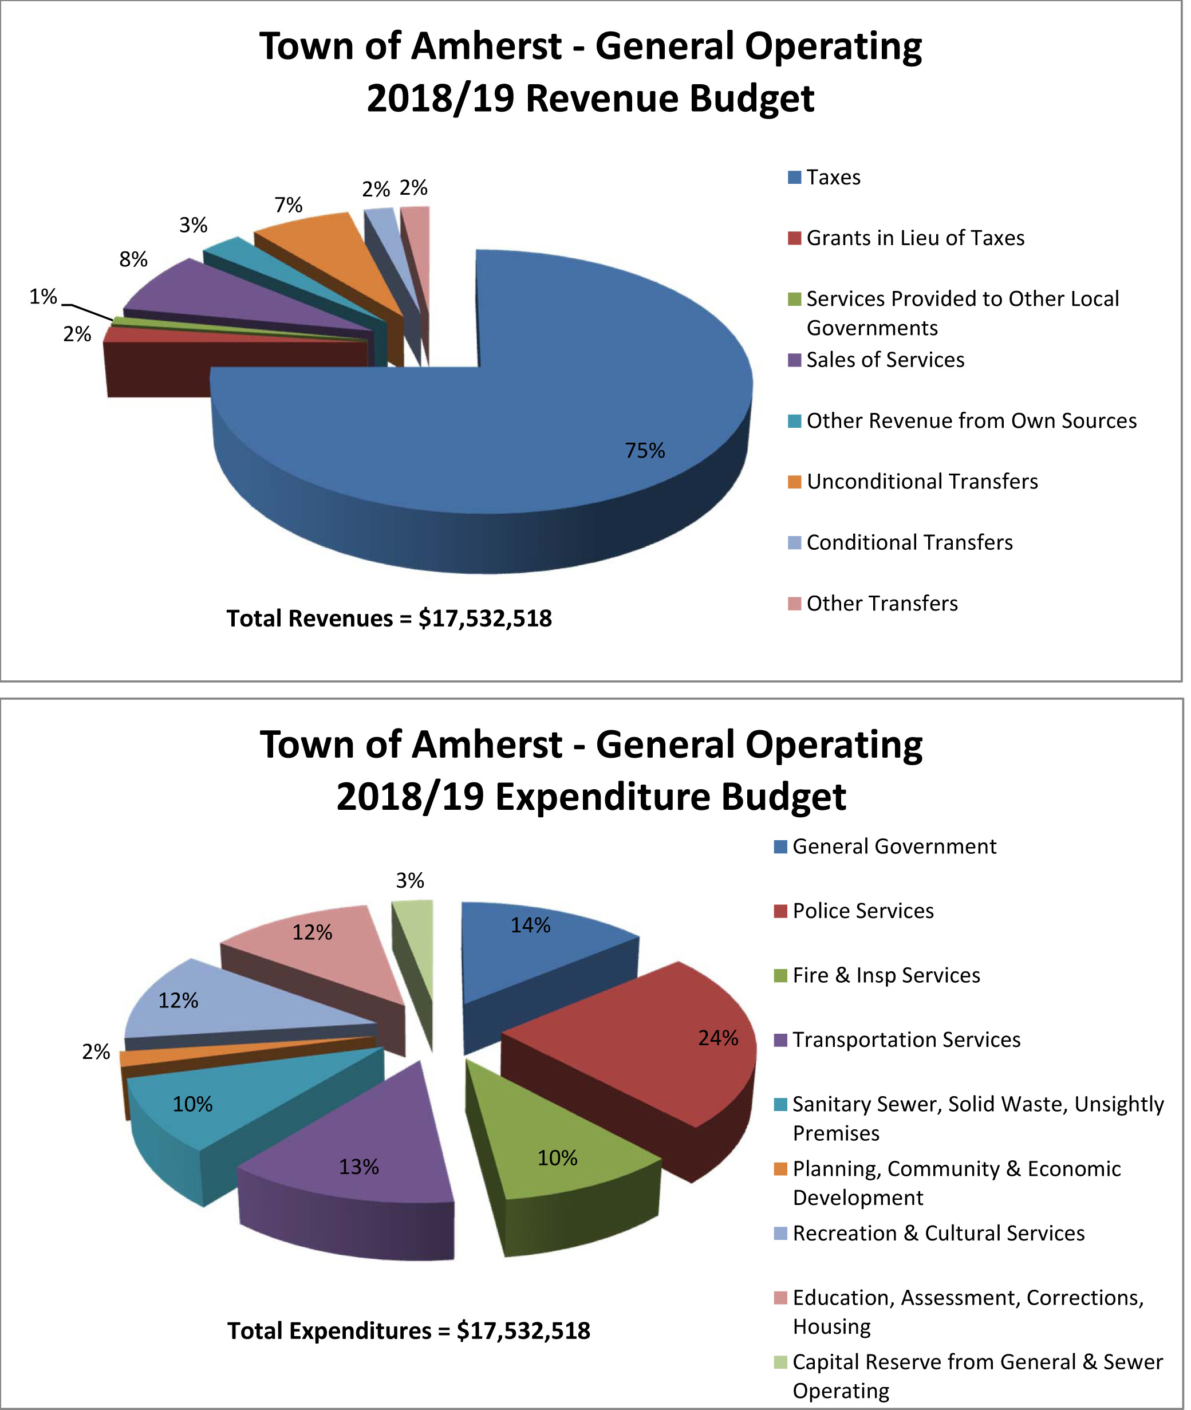The operating budget experienced a 0.3 per cent decrease, dropping to $17,532,518 from $17,580,588 the year before. This is mainly due to the removal of the Cumberland Regional Economic Development Association wind-up costs from last year.
The highest percentage in costs can be attributed to policing services, which are 24 per cent of the town’s total expenditures.
Council has budgeted $6.1 million in its water and general capital budgets to continue maintaining and upgrading the town’s infrastructure and equipment.
Among them is a $225,000 investment in the first phase of the town’s five-year active transportation strategy. The work will see gravel trails built on Robert Angus Drive, between Church and Willow Streets, and on Willow Street, from Robert Angus Drive to East Pleasant Street. An off-street asphalt trail built on South Albion Street from Robert Angus Drive to the Canadian Tire store will also be constructed.
Graph showing Town of Amherst’s 2018-19 operating revenues and expenses. (Town of Amherst graphic)

The development of the active transportation network is part of the town’s efforts to make Amherst the most active community in Nova Scotia.
Council is also investing $2.3 million in upgrades to Willow Street between Spring Street and the Amherst Regional High School. The improvements include replacing the water main, installing a culvert at Dickey Brook and improving the sanitary sewer lines as well as installing curbs, paving the street and replacing sections of the sidewalk.
In addition, council has budgeted $805,000 to improve the section of East Pleasant Street between Church Street and Central Avenue. The work includes replacing the water main, sanitary sewer and storm sewer as well as street reconstruction.
Council has also budgeted $340,000 for upgrades to streets and sidewalks in other parts of the town.
With the 2019 Fred Page Cup being hosted in Amherst, the stadium will also see enhancements. Council is investing $90,000 for a new sound system, $55,000 to replace the aging dehumidifiers that are reaching the end of their useful lives, $30,000 to recondition the ice plant, $25,000 to fix the rink boards and $22,000 to upgrade the Wi Fi.
The Amherst Water Utilities’ $2.1-million budget was also approved by council. It’s up 6.1 per cent from the previous year.
The quarterly water rates, as established by the Nova Scotia Utility and Review Board in June 2017, will see a base charge of $80.24 for un-metered customers, while the base charge for metered customers ranges from $30.74 to $2,529.69 depending on the size of the water meter. The water consumption rate is set at 72.8 cents per cubic metre of water consumed.
Sewer rates will remain the same with the residential rate set at 99 cents per cubic metre of water consumed and the commercial rate at 49 cents per cubic metre of consumption. For non-metered customers in unmetered mobile home parks, the park owner shall pay $178.53 per dwelling unit per annum.
The uniform charge for solid waste management has been set at $175. This is up $15 from last year’s rate of $160. It was impacted by an increase in tipping fees charged by the Cumberland Joint Services Management Authority that was necessitated by the fire at the recycling facility last year.
Kogon and Herrett both commended the town’s senior management team and staff for the excellent work they did in preparing the budget, which Herrett said focuses on the priorities of council and “specifically on increasing contributions to the community and to support poverty reduction in Amherst.”
-30-

Direct Inquiries to:
Tom McCoag
Corporate Communications Officer
902-694-6265
tmccoag@amherst.ca
Amherst.ca

